**Name: HARNAM KAUR Enrollment No: 00423207218 Class: CSE1**

**PYTHON INTRODUCTION LAB (ASSIGNMENT 1)**

**PROBLEM SATEMENT:**

Create a program that ask user to enter their name and their age. Print out a message addressed to them that tells them the year that they will turn 100 years old.

Extras:

1. Add on to the previous program by asking the user for another number and printing out that many copies of the previous message.
2. Print out that many copies of the previous message on separate line. (Hint : the string “/n is the same as pressing the ENTER button)

**PSEUDOCODE:**

**import** **datetime**

*## Question1*

**def** printName():

name = input("Enter your name: **\t**")

age = int(input("Enter your age: **\t**"))

number = int(input("Enter the number of times you want to print the message addressed that tells you the year that you will turn 100 years old. **\t**"))

age_100 = (datetime.datetime.now ().year) + (100-age)

print("Hi! "+name+ ", and you will be turn 100 years old in "+ str(age_100)+"**\n**")

print("Printing Multiple Copies **\n**")

**for** i **in** range(number):

print("Hi! "+name+ ", and you will be turn 100 years old in "+ str(age_100)+"**\n**")

printName()

**PROGRAM SCREENSHOT:**

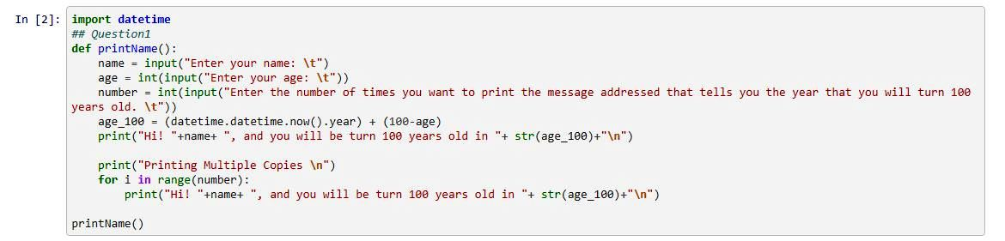

**OUTPUT:**

Enter your name: HARNAM KAUR

Enter your age: 22

Enter the number of times you want to print the message addressed that tells you the year that you will turn 100 years old. 20

Hi! HARNAM KAUR, and you will be turn 100 years old in 2099

Printing Multiple Copies

Hi! HARNAM KAUR, and you will be turn 100 years old in 2099

Hi! HARNAM KAUR, and you will be turn 100 years old in 2099

Hi! HARNAM KAUR, and you will be turn 100 years old in 2099

Hi! HARNAM KAUR, and you will be turn 100 years old in 2099

Hi! HARNAM KAUR, and you will be turn 100 years old in 2099

Hi! HARNAM KAUR, and you will be turn 100 years old in 2099

Hi! HARNAM KAUR, and you will be turn 100 years old in 2099

Hi! HARNAM KAUR, and you will be turn 100 years old in 2099

Hi! HARNAM KAUR, and you will be turn 100 years old in 2099

Hi! HARNAM KAUR, and you will be turn 100 years old in 2099

Hi! HARNAM KAUR, and you will be turn 100 years old in 2099

Hi! HARNAM KAUR, and you will be turn 100 years old in 2099

Hi! HARNAM KAUR, and you will be turn 100 years old in 2099

Hi! HARNAM KAUR, and you will be turn 100 years old in 2099

Hi! HARNAM KAUR, and you will be turn 100 years old in 2099

Hi! HARNAM KAUR, and you will be turn 100 years old in 2099

Hi! HARNAM KAUR, and you will be turn 100 years old in 2099

Hi! HARNAM KAUR, and you will be turn 100 years old in 2099

Hi! HARNAM KAUR, and you will be turn 100 years old in 2099

Hi! HARNAM KAUR, and you will be turn 100 years old in 2099

**Github Link of Jupyter Notbook:**

[**https://github.com/Harnam99/Python_Lab**](https://github.com/Harnam99/Python_Lab)

[**https://github.com/Harnam99/Python_Lab/blob/main/Question1.ipynb**](https://github.com/Harnam99/Python_Lab/blob/main/Question1.ipynb)

[**http://localhost:8890/notebooks/Desktop/Python_LabML/Question1.ipynb**](http://localhost:8890/notebooks/Desktop/Python_LabML/Question1.ipynb)

**PROBLEM SATEMENT:**

Take a list, say for example this one:

a =[1,1,2,3,5,8,13,21,34,55,89] and write a program that prints out all the elements of the list that are less than 5.

Extras:

1. Instead of printing the elements one by one, make a new list that has all the

elements less than 5 from this list in it and print out this new list.

2. Write this in one line of Python.

3. Ask the user for a number and return a list that contains only elements from the

original list a that are smaller than that number given by the user.

**PSEUDOCODE:**

*## Question 2*

**def** printele(lst):

*# Printing Elements Less than 5*

new_lst = []

**for** i **in** lst:

**if** i<5:

print(i)

*##1. Appending in List*

new_lst.append(i)

print("New List is **{}**".format(new_lst))

*##2. Appending in one line*

new_lst2 = [x **for** x **in** lst **if** x<5]

print("New List in one line is**{}**".format(new_lst2))

*##3. Asking user and responding accordingly*

number = int(input("Enter the number to find ele smaller than the number"))

new_lst3 = [x **for** x **in** lst **if** x<number]

print("Elements smaller than **{}** are **{}**".format(number, new_lst3))

a = [1, 1, 2, 3, 5, 8, 13, 21, 34, 55, 89]

printele(a)

**PROGRAM SCREENSHOT:**

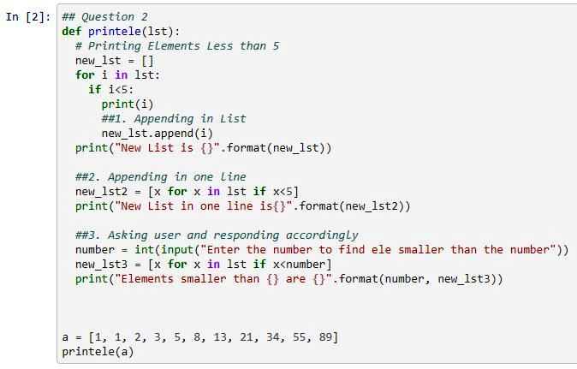

**OUTPUT:**

1

1

2

3

New List is [1, 1, 2, 3]

New List in one line is[1, 1, 2, 3]

Enter the number to find ele smaller than the number8

Elements smaller than 8 are [1, 1, 2, 3, 5]

**Github Link of Jupyter Notbook:**

[**https://github.com/Harnam99/Python_Lab**](https://github.com/Harnam99/Python_Lab)

[**https://github.com/Harnam99/Python_Lab/blob/main/Question2.ipynb**](https://github.com/Harnam99/Python_Lab/blob/main/Question2.ipynb)

[**http://localhost:8890/notebooks/Desktop/Python_LabML/Question2.ipynb**](http://localhost:8890/notebooks/Desktop/Python_LabML/Question2.ipynb)

**PROBLEM SATEMENT:**

Write a program that asks the user how many Fibonacci numbers to generate and

then generates them. Take this opportunity to think about how you can use functions.

Make sure to ask the user to enter the number of numbers in the sequence to

generate.(Hint: The Fibonacci sequence is a sequence of numbers where the next number

in the sequence is the sum of the previous two numbers in the sequence. The sequence

looks like this: 1, 1, 2, 3, 5, 8, 13, …)

**PSEUDOCODE:**

*## Question 3 Fibonacci series*

**def** fibo(n):

**if** n <= 1:

**return** n

**else**:

**return**(fibo(n-1) + fibo(n-2))

nterms = int(input("Enter the number of numbers for seq."))

print("Fibonacci sequence:")

**for** i **in** range(nterms):

print(fibo(i))

**PROGRAM SCREENSHOT:**

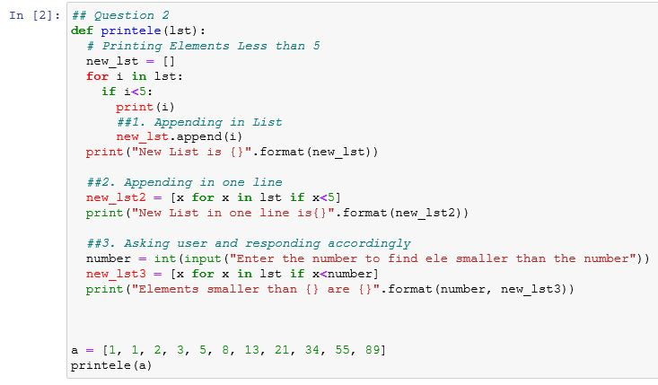

**OUTPUT:**

Enter the number of numbers for seq.12

Fibonacci sequence:

0

1

1

2

3

5

8

13

21

34

55

89

**Github Link of Jupyter Notbook:**

[**https://github.com/Harnam99/Python_Lab**](https://github.com/Harnam99/Python_Lab)

[**https://github.com/Harnam99/Python_Lab/blob/main/Question3.ipynb**](https://github.com/Harnam99/Python_Lab/blob/main/Question3.ipynb)

[**http://localhost:8890/notebooks/Desktop/Python_LabML/Question3.ipynb**](http://localhost:8890/notebooks/Desktop/Python_LabML/Question3.ipynb)

**PROBLEM SATEMENT:**

Write a program (function!) that takes a list and returns a new list that contains all the

elements of the first list minus all the duplicates.

Extras: Write two different functions to do this - one using a loop and constructing a

list, and another using sets.

**PSEUDOCODE:**

*## Question 4*

**def** lst_unique(lst):

unique = []

**for** l **in** lst:

**if** l **not** **in** unique:

unique.append(l)

**for** x **in** unique:

print(x)

**def** using_set(lst):

list_set = set(lst)

unique_list = list(list_set)

**for** x **in** unique_list:

print(x)

a = [1, 1, 2, 3, 5, 8, 13, 21, 34, 55, 89, 21, 89]

print("Without using Sets")

lst_unique(a)

**PROGRAM SCREENSHOT:**

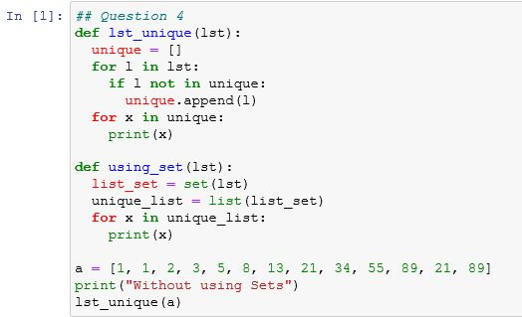

**OUTPUT:**

Without using Sets

1

2

3

5

8

13

21

3

55

89

**Github Link of Jupyter Notbook:**

[**https://github.com/Harnam99/Python_Lab**](https://github.com/Harnam99/Python_Lab)

[**https://github.com/Harnam99/Python_Lab/blob/main/Question4.ipynb**](https://github.com/Harnam99/Python_Lab/blob/main/Question4.ipynb)

[**http://localhost:8890/notebooks/Desktop/Python_LabML/Question4.ipynb**](http://localhost:8890/notebooks/Desktop/Python_LabML/Question4.ipynb)

**PROBLEM SATEMENT:**

Ask the user for a number and determine whether the number is prime or not. (For

those who have forgotten, a prime number is a number that has no divisors.). Use

functions

**PSEUDOCODE:**

*## Question 5*

**def** prime_check():

num = int(input("Enter Number you want to check **\t**"))

flag = 1

**for** i **in** range(2, int(num/2)):

**if**(num%i == 0):

flag = 0

**break**

**if**(flag==0):

print("Number is not Prime")

**else**:

print("Number is Prime")

prime_check()

**PROGRAM SCREENSHOT:**

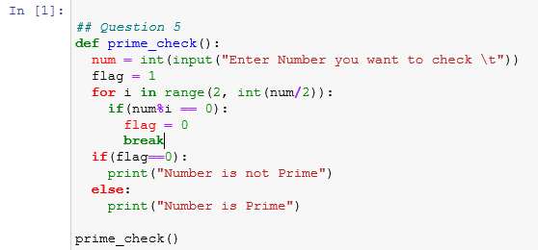

**OUTPUT:**

Enter Number you want to check 98

Number is not Prime

**Github Link of Jupyter Notbook:**

[**https://github.com/Harnam99/Python_Lab**](https://github.com/Harnam99/Python_Lab)

[**https://github.com/Harnam99/Python_Lab/blob/main/Question5.ipynb**](https://github.com/Harnam99/Python_Lab/blob/main/Question5.ipynb)

[**http://localhost:8890/notebooks/Desktop/Python_LabML/Question5.ipynb**](http://localhost:8890/notebooks/Desktop/Python_LabML/Question5.ipynb)